

Safe Swings & Fair Things
High Plains Little League Safety & Rules Quick Guide

Introduction

High Plains Little League is a nonprofit organization operated by volunteers, committed to fostering a safe, inclusive, and encouraging environment where community youth can learn and grow through the games of baseball and softball.

Safety Mission:

High Plains Little League is committed to providing a safe environment for all participants by promoting safety awareness, providing education and training, and enforcing Little League Baseball® safety rules and regulations. It is the policy of High Plains Little League to reduce the risk of injury to players, volunteers, and spectators to the greatest extent possible. Through the cooperative efforts of the Safety Officer, Safety Committee, league officials, managers, coaches, parents, volunteers, and players, safety is a fundamental priority of the league.

High Plains Little League Safety

Pre-Season/Regular Season/All Stars/Challenger

Manager & Coach Safety Responsibilities:
Managers and coaches play a key role in keeping players safe and are responsible for the following:
- Receive and maintain the HPLL Safety Manual and team First Aid Kit at all practices and games (pre-season, regular season, and All Stars)
- Meet with parents and players before the season starts to review and explain the HPLL Code of Conduct
- Attend mandatory First Aid and CPR/AED training provided by HPLL, with at least one team representative—coach, assistant coach, or Team Safety Officer (TSO)—required to participate each year.
- Appoint a volunteer parent to serve as Team Safety Officer (TSO) who can attend all games and has access to a cell phone for emergencies. If no TSO is appointed, the manager assumes these duties.
- Meet with parents and players before the first practice to review Safe Play guidelines and collect important medical information, including medications and safety concerns.
- Complete required training in concussion recognition in accordance with Colorado’s Jake Snakenberg Youth Concussion Act.
- Teach players proper fundamentals of the game with an emphasis on safety such as:
Fundamental | Focus / Notes
Catching fly balls | Proper glove technique, tracking the ball
Fielding ground balls | Proper stance, glove positioning, and footwork
Throwing mechanics | Correct arm motion, accuracy, and follow-through
Sliding | Safe and correct sliding technique (for older divisions)
Pitching motion | Simple motion for balance and control (older divisions)
Batting | Stance, swing mechanics, follow-through, and timing
T-Ball-specific fundamentals | Hitting off a tee, basic stance, hand-eye coordination  running the bases, field awareness
- Ensure that any player with a suspected concussion does not return to practice or games without a doctor’s note. For all other injuries or illnesses, the team manager and parents should assess the situation, with guidance from the Safety Officer as needed
- Work closely with the Equipment Officer to ensure all HPLL supplied equipment is in proper working order.
- Ensure telephone access is available at all activities, including practices; having a cell phone on hand is recommended.
- Set expectations that match the players’ abilities—do not expect more than they can safely perform.
- Encourage, but do not require, players to bring water bottles to practices and games, wear mouthguards and heart protectors, and have sunscreen provided by their parents.
- Always have the First-Aid Kit and Safety Manual available during practices and games.

* League support is available. For more information on coaching fundamentals, please contact our Coaching Coordinator, Brett Reed. His contact information can be found in the back of this manual

Umpire Safety Responsibilities:
• Ensure catchers are wearing all required safety gear when warming up pitchers.
• Check helmets for cracks, ensure foam inserts are in place, and confirm helmets meet Little League specifications.
• Walk the field to identify hazards or obstructions (e.g., rocks, glass).
• Check that players are not wearing jewelry.
• Verify that players are not wearing metal cleats (except in Intermediate/Junior divisions where allowed).
• Secure official Little League balls from both teams and check for discoloration or nicks; remove unfit balls from play.
• Verify that the pre-game safety checklist was completed by the managers or coaches.
• If the Safety Officer is not present the umpire is the sole judge of resuming, or terminating play due to:
- Unsuitable weather or field conditions
- Low visibility, darkness, or other safety concerns
• Enforce the rule that no spectators are allowed on the field during play.
• Continuously monitor the field for safety and playability throughout the game.
• Make calls loud and clear, signaling each properly.
• Ensure players and spectators keep their fingers and hands away from fencing.
Volunteer Safety Responsibilities:
All chartered Little League programs must adhere to the following to remain affiliated with Little League Baseball and Softball:
- Complete Background Checks
  - Conduct annual background checks on all volunteers using the Little League Volunteer Application form.
  - Prohibit anyone with disqualifying offenses from participating in any Little League activity.
  - All background checks must be completed through JPD.
  - Volunteers may submit applications online through our Volunteer Coordinator Jordan Moore.
- Mandatory Training & Continuing Education
  - Require all volunteers to complete annual Abuse Awareness Training provided by USA Baseball or an equivalent program.
- Mandatory Reporting Requirements
  - Report any suspected child abuse, including sexual abuse involving a minor, to the appropriate authorities within 24 hours.
- Non-Retaliation Policy
  - Prohibit retaliation against anyone making a “good faith” report of child abuse.
- Limit One-on-One Interactions
  - Adopt a policy that prevents one-on-one contact with minors unless in an observable and interruptible environment with another adult present.
Background checks must be completed before any volunteer participates on the field. Coaches or managers who allow volunteers to engage without a completed background check may face disciplinary action, up to and including removal from their coaching position

First Aid:

What is First Aid?
First aid is the initial care given to someone who is injured or becomes sick. It’s usually provided by the first person on the scene until professional help arrives.
- Stay within your limits: Only do what you know how to do safely. Don’t try procedures you aren’t trained for.
- Call 911 immediately: The average response time for emergency services is 10–15 minutes. Paramedics are trained to provide advanced care and communicate with the hospital while on the way.
- Do not transport the injured person: Wait for trained professionals to arrive. Your job is to provide basic first aid and keep the person safe until help comes.
Remember: your main goal is to keep the injured or sick person safe and comfortable until professional help arrives.
First Aid Kits:
First Aid Kits will be furnished to each team at the beginning of the season. The First Aid Kit will become part of the team’s equipment package and shall be taken to all practices, batting cage practices, games (whether season or post-season) and any other HPLL event where children’s safety is at risk.
If you are missing any of the above items, contact the HPLL safety officer immediately. Two additional First-Aid Kits will be available, one in the concession stand and one in the connex.. Materials from these additional kits may not be used to replenish materials in the team’s kit but only used in emergency situations.
First Aid Kits and this Safety Manual must be turned in at the end of the season along with your equipment package.

The First Aid Kit will be provided by HPLL and will include the following:
- 2 Chemical Cold Packs
- Gauze
- Athletic Tape
- Bandages
- Gloves
- Antiseptic Wipes/cleaner
- Neosporin
- Scissors
- Band-Aids
- Nose Tampons for nose bleeds

First Aid Dos and Don’ts
Dos:
• Assess the situation and the injury:
- If the player is conscious, calmly ask what happened, where it hurts, and how they are feeling.
• Know your limitations and stay within your level of training.
• Call 911 immediately if the player is unconscious, seriously injured, or in severe distress.
• Observe for signs of injury, such as:
- Bleeding
- Bruising or swelling
- Deformities in joints or bones
- Disorientation or confusion
- Difficulty breathing
• If the player is conscious, listen carefully to their description of what happened and where it hurts. Calm and reassure the child if they are upset.
• Gently feel the injured area for swelling or unusual movement, but avoid causing further pain.
• After the incident, talk to the team if they were affected by what happened. Players may be worried or upset, and it’s important they understand the situation and feel safe.

Don’ts:
- Administer any medications.
- Provide any food or beverages (other than water).
- Hesitate in giving aid when needed.
- Be afraid to ask for help if you’re not sure of the proper procedure, (i.e., CPR, etc.)
- Transport injured individual except in extreme emergencies.

Concussion Information
What is a concussion?
A concussion is a type of traumatic brain injury (TBI) caused by a bump, blow, or jolt to the head—or by a hit to the body that causes the head and brain to move rapidly back and forth. This sudden movement can make the brain shift or twist inside the skull, leading to chemical changes and sometimes stretching or damaging brain cells. Symptoms can appear immediately or over a few days.
Prevention Tips:
- Ensure athletes always wear batting helmets that fit properly and are in good condition.
- Teach athletes proper fielding techniques and strategies to avoid collisions with other players.
- Work with the managers, coaches, and umpires to remove tripping hazards.
- Ensure all equipment has padding and is in good condition.
Note:
The chart below shows that most injuries in baseball and softball occur to the head, face, and neck. Proper helmets, face guards, and awareness of safe play can help reduce these injuries.

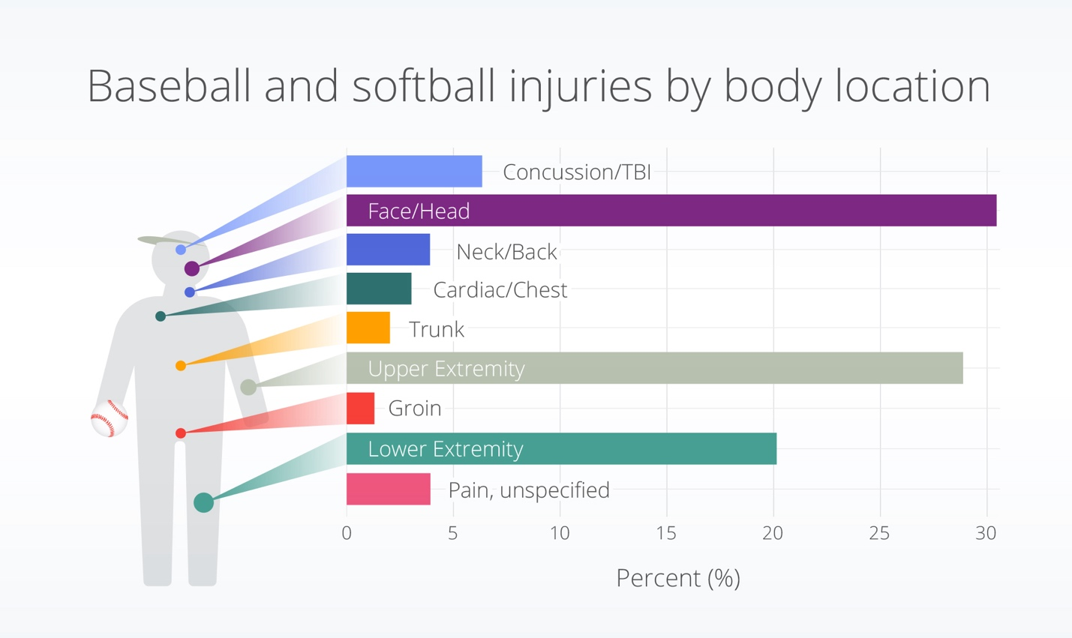

Symptoms of a Concussion:

Category | Signs & Symptoms
Physical | - Bothered by light or noise  - Dizziness or balance problems  - Fatigue or low energy  - Headaches  - Nausea or vomiting (early on)  - Vision problems
Thinking & Memory | - Difficulty paying attention or concentrating  - Feeling slowed down  - Foggy or groggy  - Problems with short- or long-term memory  - Trouble thinking clearly
Social & Emotional | - Anxiety or nervousness  - Irritability or easily angered  - Feeling more emotional than usual  - Sadness
Sleep | - Sleeping more or less than usual  - Trouble falling asleep
School-Aged Children & Adolescents (5–17) | - Appearing dazed, stunned, or confused  - Difficulty remembering or concentrating on usual activities  - Answering questions slowly  - Clumsiness or unsteady on feet  - Vomiting shortly after injury  - Slowed reaction times  - Mood, behavior, or personality changes
Danger Signs – Call 911 Immediately | - Seizures or convulsions (shaking/twitching)  - Inability to recognize people or places  - Repeated vomiting  - Unusual behavior, confusion, restlessness, or agitation  - Loss of consciousness or extreme drowsiness  - Slurred speech, weakness, numbness, or loss of coordination  - Headache that worsens or does not go away  - One pupil larger than the other or double vision

When in Doubt, Sit Them Out!

Return-to-Play After a Concussion
Athletes should only return to sports practices with the approval and supervision of their healthcare provider. The return-to-play process is gradual and may take days, weeks, or months, depending on the athlete’s recovery.

Step 1: Return to Regular Activities
- Athlete resumes regular daily activities (such as school) with approval from their healthcare provider.
- Begin with 2–3 days of rest, followed by light activity (e.g., short walks) and moderate activity (e.g., stationary bike) that do not worsen symptoms.
- Learn more: CDC Heads Up Resources

Step 2: Light Aerobic Activity
- Light exercise to increase heart rate for 5–10 minutes (e.g., walking, light jogging, stationary bike).
- No weightlifting at this stage.

Step 3: Moderate Activity
- Activities that raise heart rate and involve some body or head movement.
- Examples: moderate jogging, brief running, moderate-intensity stationary biking, reduced weightlifting (less weight or shorter duration).

Step 4: Heavy, Non-Contact Activity
- Add high-intensity, non-contact physical activity.
- Examples: sprinting, high-intensity stationary biking, full weightlifting routine, non-contact sport-specific drills in multiple planes of movement.

Step 5: Practice & Full Contact
- Athlete may participate in controlled practice and full contact (if appropriate for the sport).

Step 6: Return to Competition
- Athlete may resume full competition once cleared by a healthcare provider. The doctors note must be submitted to the Safety Office before play can resume.

Good Samaritan Laws:
Good Samaritan Laws protect people who provide emergency care from being sued, as long as they act reasonably and within their training. Always check the scene, call 911, and provide care only within your abilities. Ask a conscious victim for permission before helping; for children or unconscious individuals, permission is implied. These laws generally protect rescuers unless actions are grossly negligent, reckless, or care is abandoned.

Emergency Call Procedure:
The most important help you can provide to a seriously injured person is to call for professional medical help immediately. Make the call quickly, preferably from a cell phone near the injured person. If that’s not possible, send someone else to call from a nearby phone.
Steps to Follow:
- Dial 911
- Provide the dispatcher with key information:
  - Exact location or address of the emergency:
Falcon Regional Park – 10990 Eastonville Road, Elbert, CO
Woodmen Hills Elementary – 8303 Del Rio Road, Falcon, CO
Meridian Ranch Elementary – 10480 Rainbow Bridge Drive, Falcon, CO
Falcon Middle School – 9755 Towner Avenue, Falcon, CO
Patriot Learning Center – 11990 Swingline Rd, Falcon, CO
UCCS – 1420 Austin Bluffs Pkwy, Colorado Springs, CO
UCHealth Park – 4385 Tutt Blvd, Colorado Springs, CO
  - Telephone number from which the call is being made
  - Caller’s name
  - What happened (brief description, e.g., baseball injury, fall, bicycle accident)
  - Number of people involved
  - Condition of the injured person (e.g., unconscious, chest pain, severe bleeding)
  - First aid being provided
- Do not hang up until the dispatcher ends the call. They may give instructions for care.
- Continue providing care until professional help arrives.
- Appoint someone to meet and flag down the ambulance or fire engine to save valuable time.
Note: A map of each field is included in the appendix for quick reference.

Additional Emergency Information
FOR EMERGENCIES CALL 911

NON-EMERGENCY NUMBERS
Poison Control Center (800) 222-1222
Police Department (719) 390-5555
Fire Department (719) 495-4050

LOCAL HOSPITALS
Common Spirit St. Francis Hospital 6001 E Woodmen Rd (719) 776-5000
UCHealth Memorial Hospital North 4050 Briargate Pkwy (719) 364-5000

LOCAL URGENT CARE
UCHealth Urgent Care – Falcon 11605 Meridian Mkt View (719) 364-9560
Falcon Urgent Care 7475 McLaughlin Rd (719) 495-9994

Weather Policy
All weather decisions should be made using the WeatherBug app.

Weather Bug App
 Apple App Store  Google Play Store

HPLL give the responsibility to make a final decision to the umpire when a mutual decision cannot be made by the coaches and the Safety Officer is not present pertaining to weather cancelations/delays.

Condition | What to Do
Rain | - Assess rain intensity (drizzle vs. heavy rain). - Monitor field conditions for safety as the field becomes saturated. - Stop practice if conditions become unsafe. - During games, consult with the opposing manager and umpire.- Cancel play if rain creates safety concerns.
Lightning / Thunder | - If thunder is heard or lightning is seen, check the WeatherBug app.- If lightning is within 5 miles, stop all practices and games immediately. - Direct everyone to walk (not run) to their vehicles. - Leave equipment on the field until weather clears. - Resume play only after 15 minutes have passed since the last lightning strike. - If the game is canceled, retrieve equipment before leaving.
Cold Weather | - Cancel games/practices when:  • T-Ball and Rookies: 40 degrees feels like 35 (with wind chill)  • All other Divisions: 35 Degrees feels like 32 (with wind chill)
Hot Weather | - Games are usually not canceled. - Encourage frequent water breaks between innings. - Remove players showing signs of heat distress and move them to shade immediately. - If a player collapses due to heat exhaustion, call 911 immediately, give water, and apply ice packs until help arrives.
Darkness | - Playing on unlit fields may create safety hazards. - Use common sense and consult with the umpire to decide whether to suspend or cancel play due to low visibility.

Pitching
Baseball:
Player safety is the top priority at HPLL. To protect our athletes, we follow the Pitch Smart pitching guidelines.
- Manager Responsibility: Report each player’s name and pitch count to the HPLL Vice President within 24 hours after every game.
- Consequences for Not Reporting:
  - First offense: Warning
  - Second offense: One-game suspension
  - Third offense: Possible removal of coaching privileges
Pitch Smart Guidelines – Baseball
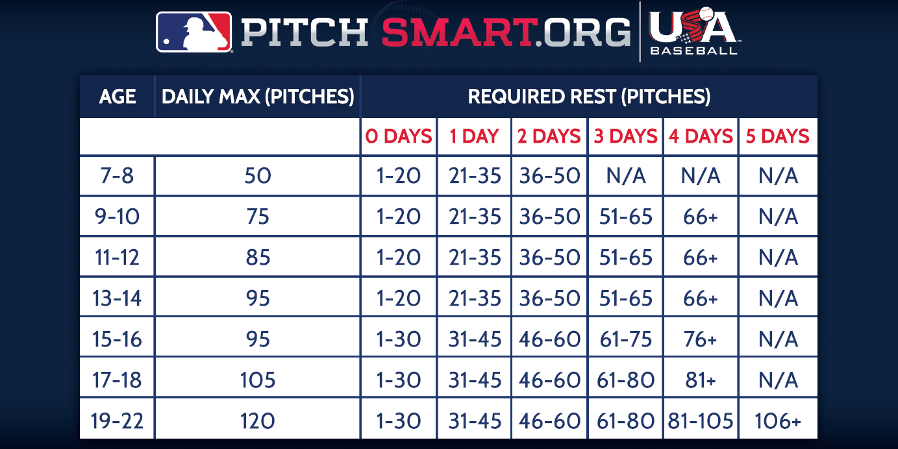
*Ages 15-16 Senior ages cannot pitch in Juniors division.

Notes for Coaches & Parents:
- Rest days are full calendar days between pitching appearances.
- Pitch counts are based on the player’s age, not their division.
- It is the coach’s responsibility to monitor and report pitch counts accurately and honestly.
- • Failure to properly track or report pitch counts may result in suspension or removal of coaching privileges.
- Follow these guidelines strictly to protect young arms and prevent injury.
- Always monitor your pitcher for fatigue or soreness, even if the pitch count is within limits.
- For more information, visit Little League Pitch Smart
If a pitcher reaches the limit imposed for his/her league age while facing a batter, the pitcher may continue to pitch until any of the following conditions occur:
- Batter reached base
- Batter is out
- The third out is made completing the half inning or the game
- The pitcher is removed from the mound prior to the batter completing his/her bats
Any player who has played the position of catcher in four or more innings in a game is not eligible to pitch on that calendar day.

A player who played the position of catcher for three innings or less moves to the pitcher position and delivers 21 pitches or more (15–16-year-olds: 31 pitches or more) in the same day may not return to the catcher position on that calendar day.

The Pitch Log must be filled out accurately each game. Log is Located at the Back of Coach’s Binder.
If you have any concerns on pitch count please reach out to the HPLL Vice President.

Softball:

Regular Season Softball Pitching Rules
1. Who Can Pitch:
- Any player on the team roster may pitch.
- Exceptions:
  - Minor League: Players aged 12 cannot pitch.
  - Junior League: Some leagues may prohibit 15-year-olds from pitching.
2. Minors/Majors:
- Maximum of 12 innings pitched per day.
- Rest rule: If a player pitches 7 or more innings in a day, 1 calendar day of rest is required.
- Note: A single pitch counts as having pitched in an inning.
3. Days of Rest Example (7+ Innings Pitched):

Column A – Day Pitched | Column B – Eligible to Pitch Again
Sunday | Tuesday
Monday | Wednesday
Tuesday | Thursday
Wednesday | Friday
Thursday | Saturday
Friday | Sunday
Saturday | Monday
4. Junior/Senior League:
- No pitching restrictions apply unless imposed by the local league or district.
5. Special Rule for 12-Year-Old Pitchers:
- If a 12-year-old pitches in Majors, Junior, or Senior League, all innings across divisions count toward their pitch limit and rest requirements.
Equipment

The Equipment Officer, an elected HPLL Board Member, is responsible for purchasing and distributing league equipment to each team. While all equipment is checked when issued, managers are responsible for maintaining and inspecting it before every practice and game.
Damaged or poorly fitting equipment will be replaced promptly. Please contact HPLL Equipment Officer, if replacements are needed.
Players may use personal equipment only if it meets the safety standards outlined in this Safety Manual and the Official Little League Rule Book
Required Player Equipment:
- Protective cups: Metal, plastic, or fiber cups are required for all male players in the Minors division and above.
- Catcher’s helmet and mask: Must include a dangling throat guard. Skull caps are not permitted. Required during pitcher warm-ups, infield practice, and while the batter is in the box.
- Catcher’s mitt: Required for all baseball catchers.
- Chest and leg protectors: Required for all catchers while the batter is in the box. Long-style chest protectors are required for Little League Majors and younger.
- Batting helmets: Must meet NOCSAE standards and be worn by all batters, base runners, and players in the coach’s box.
- Baseballs: Must be regulation size for the division being played and marked RS (regular season) or RS-T (regular season/tournament).
- Bats: Must be regulation size and display the USA Baseball logo.

- Softball face masks: Required for all softball players.
Bat Rules: Baseball:
The bat must be a baseball bat which meets the USA Baseball Bat standard (USA Bat) as adopted by Little League. It shall be a smooth, rounded stick, and made of wood or of material and color tested and proved acceptable to the USA Baseball Bat standard (USA Bat).
Beginning with the 2018 season, non-wood and laminated bats used in the Little League (Majors) and below, Intermediate (50-70) Division, Junior League divisions, and Challenger division shall bear the USA Baseball logo signifying that the bat meets the USA Bat – USA Baseball’s Youth Bat Performance Standard. All BPF – 1.15 bats will be prohibited beginning with the 2018 season. Additionally, starting in 2018, the bat diameter shall not exceed 25⁄8 inches for these divisions of play. Bats mee􏰀ng the Ba􏰁ed Ball Coefficient of Restitution (BBCOR) standard may also be used in the Intermediate (50-70) Division and Junior League divisions. Additional information is available at LittleLeague.org/bat info
Choke knobs, choke up assists, or thumb protectors are considered alterations to the bat and not permitted.

Bat Rules: Softball:
The bat must be a softball bat which meets Little League specifications and standards as noted in this rule. It shall be a smooth, rounded stick and made of wood or a material tested and proved acceptable to Little League standards. The bat shall be no more than 33 inches (34 inches for Junior/Senior League) in length, not more than two and one-quarter (21⁄4) inches in diameter, and if wood, not less than fifteen-sixteenth (15/16) inches in diameter (7/8 inch for bats less than 30 inches) at its smallest part. Non-wood bats shall be printed with a BPF (bat performance factor) of 1.20. Bats may be taped or fitted with a sleeve for a distance not exceeding 16 inches from the small end. Colored bats are acceptable. A non-wood bat must have a grip of cork, tape or composition material, and must extend a minimum of 10 inches from the small end. Slippery tape or similar material is prohibited.
Choke knobs, choke up assists, or thumb protectors are considered alterations to the bat and not permitted.

Player Pool
Baseball/Softball:
To help leagues that struggle to field full teams, a player pool may be created for regular-season games. The pool will consist of HPLL players who are willing to play extra games and will be age-appropriate (for example, minors to majors, majors to intermediate).
The Player Agent will manage the pool and assign players to teams that are short players on a rotating basis. Managers and coaches may not select players themselves.

Accident Reporting
Any incident that causes any player, manager, coach, umpire or volunteer to receive medical treatment and/or first aid must be reported to the High Plains LL Safety Officer. This includes even passive treatment such as the evaluation and diagnosis of the extent of the injury.
When to Report
All such incidents described above must be reported to the HPLL Safety Officer within 24 hours of the incident. The HPLL Safety Officer, Jackie Reed, can be reached at 719-339-4542

How to Make a Report
Reporting incidents can come in a variety of forms. Most typically, they are telephone conversations. At a minimum, the following information must be provided:
- The name and phone number of the individual involved.
- Date, time and location of the incident.
- A detailed description of the incident.
- The preliminary estimation of the extent of the injuries.
- Name and phone number of the person reporting the incident

Team Manager’s Responsibility
The TSO will fill out the HPLL Accident Investigation Form and submit it to the HPLL Safety Officer at SafetyOfficer@HighPlainsLL.com within 24 hours of the incident. (Form can be found in the Appendix).
Accidents occurring outside the team (i.e., spectator injuries, concession stand injuries and 3rd party injuries) shall be handled directly by the HPLL Safety Officer.
HPLL Safety Officer’s Responsibility
Within 24 hours of receiving the Accident Investigation Form, the Safety Officer will contact the injured party or the party’s parents and do the following:
- Verify the information received.
- Obtain any additional information deemed necessary.
- Check on the status of the injured party.
- If medical treatment was required, advise the parent or guardian of the HPLL insurance coverage and the provision for submitting any claims. Insurance information will be in the appendix.
If the injury is more than minor in nature, the HPLL Safety Officer will periodically call the injured party to check on the status of the injury and check if any other assistance is needed in areas such as submission of insurance forms, etc. until the incident is considered closed (i.e. no further claims are expected and/or the individual is participating in the League again).

Please scan the QR code below to agree to the Safety Plan Rules:

Code of Conduct:
- Physical Misconduct
  - Making physical contact with, pushing, shoving, striking, or threatening to strike any umpire, official, board member, coach, player, volunteer, or spectator.
  - Engaging in or encouraging physical altercations or fights of any kind.
  - Using unnecessarily rough or dangerous tactics against an opposing player.
- Verbal Abuse and Unsportsmanlike Conduct
  - Verbally abusing, harassing, or intimidating any umpire, official, coach, player, volunteer, or spectator.
  - Publicly criticizing or arguing about umpire decisions, plays, or player performance in a derogatory or abusive manner.
  - Demonstrating dissent through unsportsmanlike actions, including but not limited to throwing gloves, helmets, bats, balls, or other equipment.
  - Speaking disrespectfully to any league representative, manager, coach, or official.
- Umpire Authority
  - Challenging or Undermining Umpire Authority: Managers, coaches, players, and spectators must not challenge or undermine the authority of an umpire. This does not include respectfully questioning or seeking clarification on a call.
  - Failing to comply with an umpire’s instructions or rulings. Umpires have full authority to penalize violations, up to and including removal from the game or premises.
- Language and Behavior
  - Using profane, obscene, vulgar, or inappropriate language at any time.
  - Making discriminatory, threatening, or harassing remarks based on race, creed, color, sex, ability, or any other protected characteristic.
  - Engaging in behavior that disrupts the game or creates a hostile or unsafe environment.
- Alcohol, Drugs, and Tobacco
  - Appearing on league premises while intoxicated or under the influence of alcohol or drugs. Intoxication may be determined by behavior or odor.
  - Possessing, consuming, or being under the influence of alcohol or illegal substances on league property.
  - Smoking, vaping, or using tobacco products in the stands, on the field, or in dugouts at any time.
- Gambling and Integrity of the Game
  - Gambling on any play, game, or outcome at any time.
  - Tampering with or attempting to manipulate league rosters, schedules, drafts, scorebooks, rankings, financial records, or league procedures.
- Coach and Manager Conduct
  - Managers or coaches fraternizing with spectators during the course of a game in a manner that distracts from their duties.
  - Failing to model appropriate behavior, sportsmanship, and respect for players and officials.
  - Encouraging or allowing players to engage in unsafe or unsportsmanlike conduct.
- Facility and Equipment Misuse
  - Damaging or misusing league property, facilities, or equipment.
  - Entering restricted areas without authorization.
  - Failing to follow league safety rules or field-use policies.
  - No climbing fences or dugout walls.
  - No swinging bats or throwing baseballs within the walkways and common areas of the complex.
  - No throwing rocks.
  - All gates to the fields should be closed at all times.
- General Conduct
  - Any behavior that compromises the safety, fairness, integrity, or enjoyment of the game.
  - Any conduct deemed inappropriate or detrimental to High Plains Little League by league officials or the Board of Directors.
  - Never hesitate to report any present or potential safety or misconduct to the HPLL Safety officer immediately.

Please scan this QR Code to agree to the above Code of Conduct:


Board Members
If at any time you have any concerns, please feel free to reach out to any of the HPLL Board Members:
Email | Name | Role
- President@HighPlainsLL.com | - Jared Holtz | - President
- VPbaseball@HighPlainsLL.com | - Scot Raffelson | - Vice President BB
- VPsoftball@HighPlainsLL.com | - Ashley Carpenter | - Vice President SB
- CoachingCoordinator@HighPlainsLL.com | - Brett Reed | - Coaching Coordinator & Player Agent
- Treasurer@HighPlainsLL.com | - Kari Carlson | - Treasurer
- InformationOfficer@HighPlainsLL.com | - April Standerfer-Holtz | - Information Officer
- Scheduler@HighPlainsLL.com | - Bobbi Lehman | - Scheduler
- Secretary@HighPlainsLL.com | - Red Carlson | - Secretary
- Volunteering@HighPlainsLL.com | - Jordan Moore | - Volunteering Coordinator
- SafetyOfficer@HighPlainsLL.com | - Jackie Reed | - Safety Officer
- EquipmentOfficer@HighPlainsLL.com | - Marco Lopez | - Equipment Officer
- UmpireCoordinator@HighPlainsLL.com | - Doug Ziegler | - Umpire Coordinator
- Fundraising@HighPlainsLL.com | - Kevin Carpenter | - Fundraising

